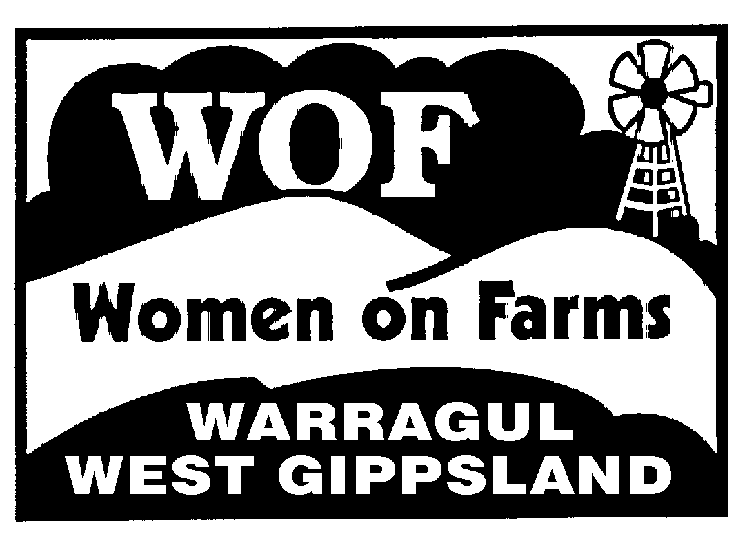
WOMEN ON FARMS WEST GIPPSLAND INC. A0037208T
ABN 76 708 765 114
Women on Farms West Gippsland Inc. is NOT GST registered
www.womenonfarms-wg.org.au

Membership applications must be made annually on this form.
On Line form available. See website.

MEMBERSHIP SECRETARY: Marion Denniss, 1658 Westernport Road, Heath Hill, 3981

Membership year: 1st December 2022 to 30th November 2023

Membership Fee.. $25.00 New member / Renewal

NAME ...…………………………………………………………………. DATE……………………
RESIDENTIAL ADDRESS . ……………………………………………………………………..……
TOWN………………………………………………............POST CODE…………
POSTAL ADDRESS (only if different) . ……………………………………………………………..
HOME PHONE NO. …………………………….
MOBILE.……….…………………………...
E-MAIL ADDRESS. …………………………………………………………………………………
YOUR TYPE OF FARMING ENTERPRISE………….………….…………………………………

THIS MUST BE SIGNED TO ENSURE MEMBERSHIP IS VALID
I apply for membership of WOFWG.
I include the correct subscription.
I agree to comply with the rules and objectives of the Association as set out in the Constitution.
I accept that articles may be published about WOFWG activities and these may include photographs of members including myself.
I accept that personal information is used by WOFWG to keep an accurate register of members, as required by the Constitution, and to pursue WOFWG’s objectives for its members.
Signed:……………………………………………..…….. Date………………….

Cheques payable to : WOFWG. Cash & Direct Deposit also accepted

Direct Deposit Accepted All deposits must have your name & payment code. M.
Bendigo Bank Please send an email to alert deposit to
BSB. 633-000 treasurer@womenonfarms-wg.org.au
Acc.No. 108 281 759

